

Course PHYSICS 1
LABORATORY REPORT

Experiment Title: Measuring the electric field strength inside a plate capacitor (P3.1.7.4).

Name of the student: Elnur Gadirli
Group number: PAE 22.1
Team Number: 06

Experiment carried out: 1 December 2023
Lab report submitted: 8 December 2023

Supervisor: Associate Prof. G. Najafov

Synopsis
This comprehensive report provides a detailed account of the experimental procedures and outcomes undertaken by Group-6 in the investigation titled "Measuring the Electric Field Strength Inside a Plate Capacitor." The ensuing narrative delves into an in-depth examination of the findings derived from meticulous laboratory work and the systematic application of pertinent equations gleaned from the laboratory leaflets.
Our primary objective is to offer a comprehensive overview of the experiment, shedding light on the various steps involved and presenting a thorough analysis of the challenges encountered during the course of our study. The report not only elucidates the practical aspects of our experiment but also expounds upon the theoretical underpinnings that guided our calculations.
By synthesizing the experiential data and methodical computations, this report seeks to provide a nuanced understanding of the undertaken experiment. Furthermore, it endeavours to offer insights into the complexities faced, contributing to a more comprehensive appreciation of both the experimental process and the inherent intricacies inherent in measuring electric field strength within a plate capacitor.
Introduction
A capacitor serves as an electronic apparatus designed to store electrical energy within an electric field, achieved through the accumulation of electric charges on two closely spaced surfaces. Among the elementary configurations of capacitors, the plate capacitor stands out as the most straightforward, comprising two parallel plates. This capacitor is integrated into a basic circuit, typically involving a power supply. The electric field generated within the capacitor is contingent upon several factors, including the area of the plates, the separation distance between them, and the nature of the dielectric material situated between the plates. These parameters collectively influence the storage and distribution of electrical energy.
The focus of our experiment lies in the deliberate alteration of the distance between the plates of the capacitor. By systematically varying this parameter, we aim to assess its impact on the electric field and subsequently calculate the electric energy stored within the capacitor. This exploration promises valuable insights into the dynamics of electric field manipulation and energy storage, elucidating the interplay between plate separation and the resultant electrical characteristics of the capacitor.

Theory
Within the context of this experiment, a circuit is employed with a voltage of 1 kilovolt (1 kV), as illustrated in Figure 1. The magnitude of the electric field (E) in this experimental setup can be determined utilizing the following formula:
$$E=\frac{Q}{ε_{0}ε_{r}A}$$
In this experiment, the magnitude of the electric field (E) is determined by the charge modulus (Q) on one of the plates, the plate area (A), the permittivity of free space ($ε_{0}$), and the dielectric constant ($ε_{r}$). It's important to note that in this particular investigation, a dielectric is not incorporated, and the sole variable under manipulation is the distance between plates (d). Consequently, an alternative formula in terms of Voltage (V) and the separation distance (d) can be utilized to calculate the electric field (E).
$$E=\frac{V}{d}$$
With the given formula in hand, we can compute the electric field (E) by employing the Voltage (V) and specifying a particular distance (d) for each test case. Additionally, an electric field meter is integrated into the circuit, providing detailed insights into the electric field. This allows us to cross-verify our calculations and ensure their alignment with the actual electric field measurements obtained from the electric field meter.
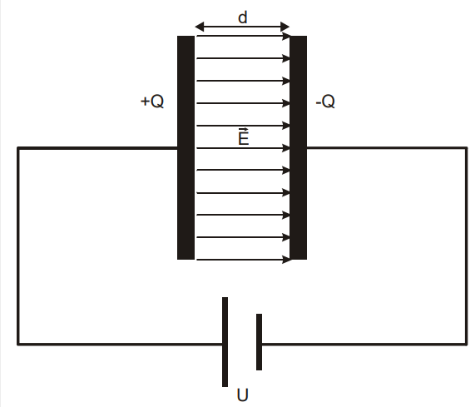

Figure 1 Circuit Diagram
Experimental techniques
Apparatus
- 1 Electric field meter S
- 1 set of accessories for the electric field meter S
- 1 Universal measuring instrument P
- 1 high voltage power supply 10kV
- 2 Clamp riders with clamp 45/35
- 1 Optical bench, S1 profile, 50cm
- 1 Safety connection lead, 10cm, yellow/green
- 1 safety connection lead, 100cm, red
- 1 safety connection lead, 100cm, blue
Setup and carrying out the experiment:
Setup:
Secure one of the capacitor plates firmly by affixing it to a stand base using a plastic stand rod, accompanied by a clamp rider equipped with a clamp on the optical bench profile S1. Subsequently, insert the drilled capacitor plate onto the electric field meter S, ensuring secure attachment using clamp riders with clamps on the optical bench profile S1. Establish a connection between the electric field meter and the universal measuring instrument P for comprehensive data acquisition.
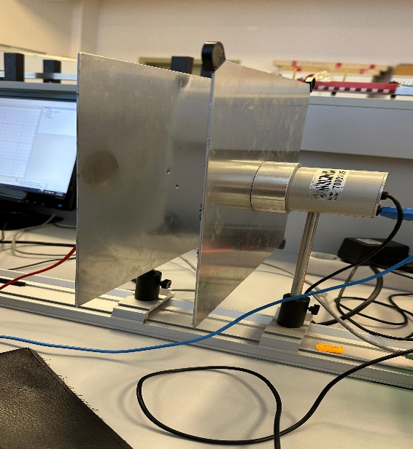

Figure 2

Carrying out:
Commence by deactivating the power supply. Utilize a measuring instrument to gauge the distance between the plates, denoted as 'd.' Activate the power supply and record the Electric field (E) as indicated by the electric field meter. Proceed to replicate this sequence for various values of 'd' to obtain a range of data points for analysis.
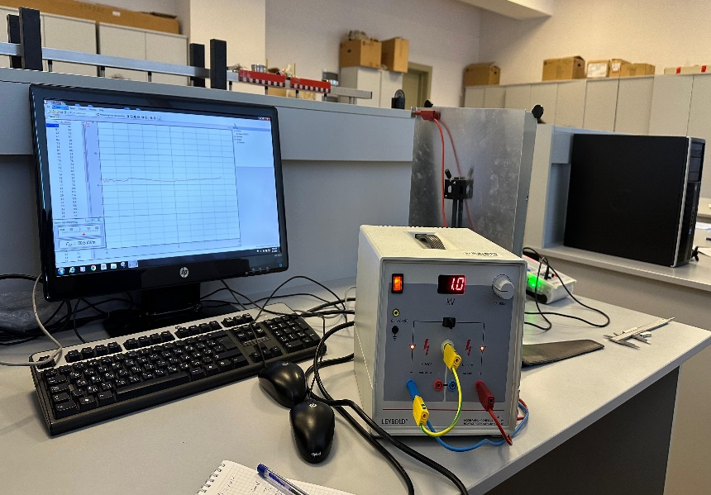

Results-Experimental and derived:
Following the provided instructions, the experiment was conducted, and the resulting data was recorded in the corresponding table.
Table 1
$$d$$  (cm) | 1.5 | 2.51 | 4.4
$E$(device)  (kV/m) | 47.7 | 21 | 11.6
E(calculated)  (kV/m) | 66.6 | 39.84 | 22.73

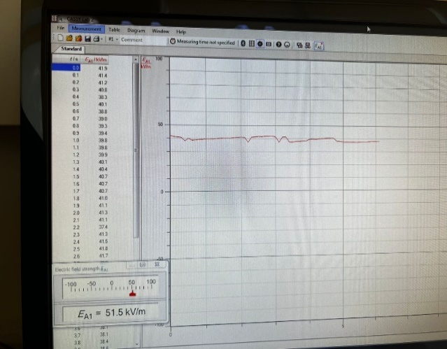
Table 1. Shows the results of the experiment.

Discussion of results
The outcomes obtained from both the experimental and calculated approaches exhibit consistency, despite not yielding identical results. In each test iteration, the electric field (E) was computed in accordance with the prescribed formula and subsequently juxtaposed with the corresponding readings obtained from the electric field measuring device. It is evident that some marginal discrepancies surfaced during our experiment, primarily attributable to the inherent fluctuation in the electric field device, resulting in imprecise measurements. This variability in readings was expected, given the device's tendency to exhibit erratic fluctuations. Furthermore, ancillary factors contributing to the observed errors encompass potential inaccuracies in the distance measuring instrument, slight deviations in the parallel alignment of plates, and other minor variables, including environmental factors such as room conditions (e.g., wind). It is imperative to acknowledge and account for these contributory elements when interpreting and contextualizing the observed variations between the calculated and measured values.
Conclusion
This laboratory experiment has effectively demonstrated the methodology for determining the electric field within a plate capacitor. Although some errors were encountered, the overarching goal of our laboratory work was successfully achieved. Every requisite quantity essential for the experiment was meticulously defined and systematically recorded in Table 1, providing a comprehensive documentation of the experimental parameters. The acknowledgment of encountered errors underscores the transparency and scientific rigor of our approach, contributing to a more nuanced interpretation of the experimental outcomes and enriching the overall depth of understanding gleaned from the investigation. table 1.
References
Laboratory leaflets
BHOS laboratory.

